Commentary on Articles and Data Visualizations Related to Politics

By: Felix Gonzalez (last updated 3/11/2024)

The commentary in this essay are the views of the Data 601 instructor Felix Gonzalez and are used for educational purposes and in the context of various topics within the Data601 class. The respective visualizations belong to the reference owners that produce and if used should reference the source of the visualization or figure and not of this commentary essay.

In many cases politics may be controversial because of various reasons including but not limited very strong beliefs and viewpoints. However, because of these same strong viewpoints and the longevity of the data available, the topic of politics has many good examples with excellent visualizations and different ways to communicate the same or very similar data. In some cases, the authors are defending a specific viewpoint while in other cases the tone of an article may be neutral and let the data speak for itself while allowing the readers reach their own conclusions. This commentary focuses data science tasks (e.g., data cleaning, exploratory data analysis (EDA) and data visualization) discussed during the Data601 class. The objective of the commentary is to show that the same data can be presented in many different ways and not to highlight advantages or disadvantages over one visualization and the other as these could be subjective.

The selected visualizations show data on U.S. Congressional party majorities over time. Some visualizations data goes back to the 1700’s. Some overall points related to all visualizations:

* There may be potential difference that may be caused by a variety of reasons including but not limited to different data sources or assumptions during data cleaning.
* Graphics and visualization experts may be part of data science teams.
* Some of these visualizations are complex visualizations and expertise may be needed to recreate.
* Some of these visualizations may be using data augmentation where datasets from various sources are being combined to create an augmented dataset.

Examples dataset on U.S. Congressional statistics can be found published in various online sources such as that published by the Brookings Institution (Brookings - Governance Studies Media Office 2022).

Figure 1 and Figure 2 show very similar data on U.S. Congressional majorities and in Office Presidents using very different visualizations. Figure 1 uses horizontal bars with various shades of colors to highlight majorities. Figure 2 uses a scatter plot over time with various shades of colors to highlight majorities. Each approach has its own set of advantages and disadvantages which may vary from person to person. Authors and readers may have their own preferences on how to visualize the dataset.

Figure : U.S. Congressional Majorities and President Past 120 Years (Apple 2023)

Figure : U.S. House of Representatives – Members by Party 1952-2014 (Bolten 2014)

Figure 3 shows party members using a histogram but uses a derived features which scores ideological views of Senators and Representatives. This score is used in the x-axis and has a range of -1 to +1. Several notes on Figure 3 include:

* There may be different methods to calculate a derived feature like in this case the “ideological” score. A knowledgeable subject matter expert or in cases special studies may be needed as part of a data science team that will plot and study and identify insights from the data.
* The “ideological” score seems to be based on a dataset called DW‑Nominate that looks at how members vote and recognize that it is not an ideal measure and may indicate high uncertainty.

Figure : Histograms of U.S. Senators and Representatives by Ideological Scores (Kleinfeld 2023)

Figure 4 and Figure 5 show the Party differences over time using a line plot. However, these show some slights differences and specific things to highlight.

Figure : U.S. Congress Party Difference over Time 1700’s to 2000’s (DeCotiis-Mauro 2018)

Figure : U.S. Congress Party Difference over Time 1700’s to 2000’s (Desilver 2023)

Figure 6 shows similar data to Figure 4 and Figure 5 but using a table format sorted by the difference or margin (in percentage points). This one highlights those Congress sessions that had the lowest differences.

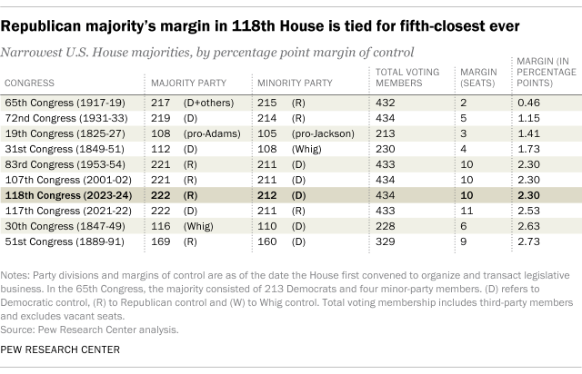

Figure : U.S. House Majorities by Percentage Point Margin of Control (Desilver 2023)

Data visualization is not an exact science. The best visualization may be subjective to the stakeholder from the author, subject matter experts, data scientists, and readers. The best answer will depend on many variables and there may be many different paths that communicate the same message and is up to you and your team to determine path it takes.

# References

Apple, Charles. 2023. *Further Review - In Control - The Spoksman-Review.* https://www.spokesman.com/stories/2020/jun/25/control-house-and-senate-1900/.

Bolten, Randall. 2014. *The U.S. House of Reps, and Data Visualization #1.* 11 10. https://www.painting-with-numbers.com/blog/the-u-s-house-of-reps-and-data-visualization-1.

Brookings - Governance Studies Media Office. 2022. *Research Vital Statistics on Congress.* 11 21. https://www.brookings.edu/articles/vital-statistics-on-congress/.

DeCotiis-Mauro, Andrew. 2018. *Congressional Partisanship: A visualization.* 1 2. https://towardsdatascience.com/congressional-partisanship-a-visualization-c7bc448fd3e.

Desilver, Drew. 2023. *Narrow Majorities in U.S. House have become more common but haven't always let to gridlock.* 5 5. https://www.pewresearch.org/short-reads/2023/05/05/narrow-majorities-in-u-s-house-have-become-more-common-but-havent-always-led-to-gridlock/.

Kleinfeld, Rachel. 2023. *Polarization, Democracy, and Political Violence in the United States: What the Research Says.* 9 5. https://carnegieendowment.org/2023/09/05/polarization-democracy-and-political-violence-in-united-states-what-research-says-pub-90457.

University of Maryland Baltimore County (UMBC). 2023. *Academic Integrity Plagiarism Education.* 4 13. https://academicconduct.umbc.edu/plagiarism/.